First Hmong Missionary Alliance Church
5500 Stettin Drive, WI 54401
(715) 842-9218
Admin@fhmacwausau.org

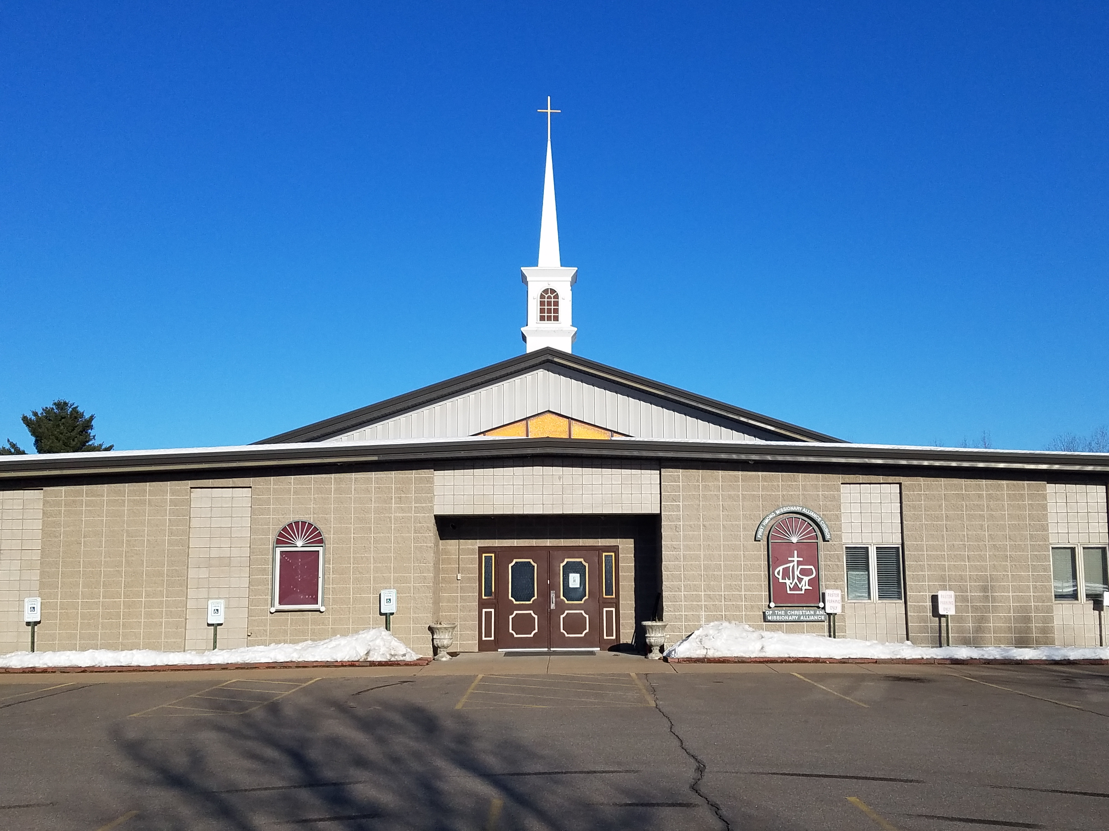

ACCIDENT WAIVER AND RELEASE OF LIABILITY FORM

I, ___________________________ (name of participant), realize that my participation in this event ______________________________ on dates from __/__/___ to __/__/_____. I further understand that on behalf of me, my family, and others who might make a claim on my behalf expressively assume any risks or property damage, injury, and/or death arising from my participation in/to traveling activities. I am knowingly and voluntarily released First Hmong Missionary Alliance Church, members of the Governing Board and its officers, Senior Pastor, Youth Pastor, employees, congregation members, volunteers, and agents (collectively, the “release Parties”), from any and claims, losses, damages, and liabilities” whether known or unknown, foreseen or unforeseen) related to my participation in and while traveling to these activities. I agree to hold harmless and indemnify the First Hmong Missionary Alliance Church and its agents for any property damages, personal injury, loss and or death arising from my participation in/or traveling to participate in this event.

In case of medical or surgical treatment is needed to protect my health and welfare while participating in and/or traveling to or coming from the activities, I authorize and agree to allow any authorized agent or employee of the First Hmong Missionary Alliance Church to consent the administering of such necessary medical and/or surgical treatment. I agree to pay for any and all expense(s) that this procedure may incur.

I acknowledge that this Accident Waiver and Release of Liability Form will be used by the event holders, sponsors, and organizers of the activity in which I may participate, and that it will govern my actions and responsibilities at said activity. In consideration of my application and permitting me to participate in this activity, I hereby take action for myself, my executors, administrators, heirs, next of kin, successors, and assigns as follows:

(A) I WAIVE, RELEASE, AND DISCHARGE from any and all liability, including but not limited to, liability arising from the negligence or fault of the entities or persons released, for my death, disability, personal injury, property damage, property theft, or actions of any kind which may hereafter occur to me including my traveling to and from this activity, THE FOLLOWING ENTITIES OR PERSONS: FIRST HMONG MISSIONARY ALLIANCE CHURCH

(B) INDEMNIFY, HOLD HARMLESS, AND PROMISE NOT TO SUE the entities or persons mentioned in this paragraph from any and all liabilities or claims made as a result of participation in this activity, whether caused by the negligence of release or otherwise. I acknowledge and unconditionally release and forever discharge any persons, entities, and their respective directors, officers, employees, agents, contractors, partners, shareholders, successors, assignees, parent or subsidiary entities, representatives, are NOT responsible for the errors, omissions, acts, or failures to act of any party or entity conducting a specific activity on their behalf.

I also affirm that I will comply with any and all verbal church/sponsors’ rules. Any violation of the above statements will result in disciplinary action(s) as deems appropriate by the sponsor(s).

I have read, agreed, and clearly understood the above statement.

I understand while participating in this activity, I may be photographed. I agree to allow my photo, video, or film likeness to be used for any legitimate purpose by the activity holders, producers, sponsors, organizers, and assigns. The Accident Waiver and Release of Liability Form shall be construed broadly to provide a release and waiver to the maximum extent permissible under applicable law.

I CERTIFY THAT I HAVE READ THIS DOCUMENT AND I FULLY UNDERSTAND ITS CONTENT. I AM AWARE THAT THIS IS A RELEASE OF LIABILITY AND A CONTRACT AND I SIGN IT OF MY OWN FREE WILL

Name of Participant (print) ____________________________________
(If under 18 years of age, please have your legal guardian sign below and type guardian name here:

Legal Guardian Name (If needed, print) ____________________

Signature/Participant or Legal Guardian _____________________Date Sign ___/____/______

